Problem Statement

Column 1 : PassengerId

Column 2 : Survived (survived=0 & died=1)

Column 3 : Pclass

Column 4 : Name

Column 5 : Sex

Column 6 : Age

Column 7 : SibSp

Column 8 : Parch

Column 9 : Ticket

Column 10 : Fare

Column 11 : Cabin

Column 12 : Embarked

You can download the data set from the below link

Titanic Data set

Problem Statement 1:

Find the average age of males and females who died in the Titanic tragedy.

SOURCE CODE:

package test;

import java.io.IOException;
import org.apache.hadoop.conf.Configuration;
import org.apache.hadoop.fs.FileSystem;
import org.apache.hadoop.fs.Path;
import org.apache.hadoop.io.IntWritable;
import org.apache.hadoop.io.LongWritable;
import org.apache.hadoop.io.Text;
import org.apache.hadoop.mapreduce.Job;
import org.apache.hadoop.mapreduce.Mapper;
import org.apache.hadoop.mapreduce.Mapper.Context;
import org.apache.hadoop.mapreduce.Reducer;
import org.apache.hadoop.mapreduce.Reducer.Context;
import org.apache.hadoop.mapreduce.lib.input.FileInputFormat;
import org.apache.hadoop.mapreduce.lib.input.TextInputFormat;
import org.apache.hadoop.mapreduce.lib.output.FileOutputFormat;
import org.apache.hadoop.mapreduce.lib.output.TextOutputFormat;

public class titanic1
{
public static void main(String[] args)
throws Exception
{
Configuration conf = new Configuration();

Job job = new Job(conf, "Averageage_survived");
job.setJarByClass(Uber1.class);

job.setMapOutputKeyClass(Text.class);
job.setMapOutputValueClass(IntWritable.class);

job.setOutputKeyClass(Text.class);
job.setOutputValueClass(IntWritable.class);

job.setMapperClass(Map.class);
job.setReducerClass(Reduce.class);

job.setInputFormatClass(TextInputFormat.class);
job.setOutputFormatClass(TextOutputFormat.class);

FileInputFormat.addInputPath(job, new Path(args[0]));
FileOutputFormat.setOutputPath(job, new Path(args[1]));
Path out = new Path(args[1]);
out.getFileSystem(conf).delete(out);
job.waitForCompletion(true);
}

public static class Map extends Mapper<LongWritable, Text, Text, IntWritable> //mapper
{
private Text gender = new Text();
private IntWritable age = new IntWritable();

public void map(LongWritable key, Text value, Mapper<LongWritable, Text, Text, IntWritable>.Context context) throws IOException, InterruptedException { String line = value.toString();
String[] str = line.split(",");
if (str.length > 6) {
this.gender.set(str[4]);
if ((str[1].equals("0")) &&
(str[5].matches("\\d+"))) {
int i = Integer.parseInt(str[5]); //key
this.age.set(i); //value
}

}

context.write(this.gender, this.age);
}
}

public static class Reduce extends Reducer<Text, IntWritable, Text, IntWritable> //reducer
{
public void reduce(Text key, Iterable<IntWritable> values, Reducer<Text, IntWritable, Text, IntWritable>.Context context)
throws IOException, InterruptedException
{
int sum = 0;
int l = 0;
for (IntWritable val : values) {
l++;
sum += val.get();
}
sum /= l; //average age
context.write(key, new IntWritable(sum));
}
}
}

Command:

hadoop jar /home/acadgild/hadoop/titanic1.jar /user/acadgild/hadoop/data.txt /user/acadgild/hadoop/titanic1

hadoop fs -cat /user/acadgild/hadoop/titanic1/part-r-00000
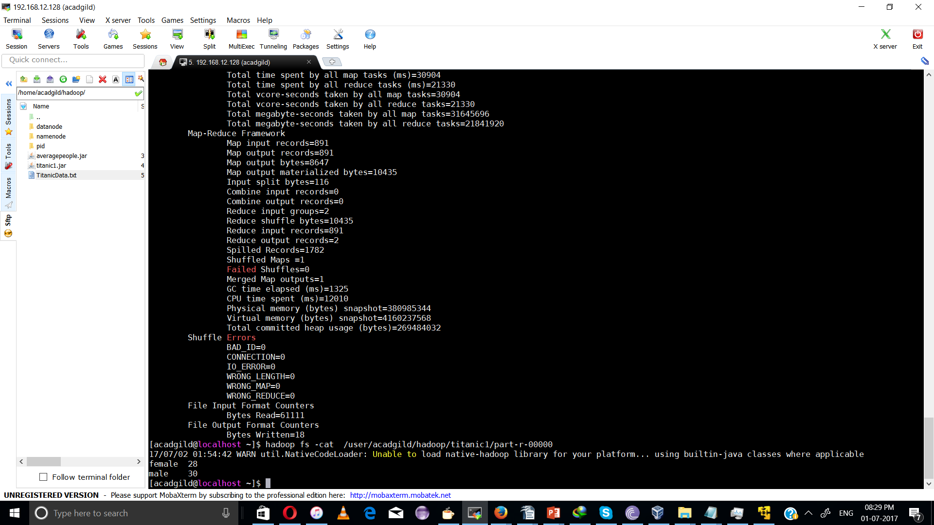

OUTPUT:

female 28
male 30

Problem Statement 2:

Find the number of people died or survived in each class with their genders and ages.

SOURCE CODE:
package test;

import java.io.IOException;
import org.apache.hadoop.conf.Configuration;
import org.apache.hadoop.fs.FileSystem;
import org.apache.hadoop.fs.Path;
import org.apache.hadoop.io.IntWritable;
import org.apache.hadoop.io.LongWritable;
import org.apache.hadoop.io.Text;
import org.apache.hadoop.mapreduce.Job;
import org.apache.hadoop.mapreduce.Mapper;
import org.apache.hadoop.mapreduce.Mapper.Context;
import org.apache.hadoop.mapreduce.Reducer;
import org.apache.hadoop.mapreduce.Reducer.Context;
import org.apache.hadoop.mapreduce.lib.input.FileInputFormat;
import org.apache.hadoop.mapreduce.lib.input.TextInputFormat;
import org.apache.hadoop.mapreduce.lib.output.FileOutputFormat;
import org.apache.hadoop.mapreduce.lib.output.TextOutputFormat;

public class Uber1
{
public static void main(String[] args)
throws Exception
{
Configuration conf = new Configuration();

Job job = new Job(conf, "females_survived");
job.setJarByClass(Uber1.class);

job.setMapOutputKeyClass(Text.class);
job.setMapOutputValueClass(IntWritable.class);

job.setOutputKeyClass(Text.class);
job.setOutputValueClass(IntWritable.class);

job.setMapperClass(Map.class);
job.setReducerClass(Reduce.class);

job.setInputFormatClass(TextInputFormat.class);
job.setOutputFormatClass(TextOutputFormat.class);

FileInputFormat.addInputPath(job, new Path(args[0]));
FileOutputFormat.setOutputPath(job, new Path(args[1]));
Path out = new Path(args[1]);
out.getFileSystem(conf).delete(out);
job.waitForCompletion(true);
}

public static class Map extends Mapper<LongWritable, Text, Text, IntWritable>
{
private Text people = new Text();
private static final IntWritable one = new IntWritable(1);

public void map(LongWritable key, Text value, Mapper<LongWritable, Text, Text, IntWritable>.Context context) throws IOException, InterruptedException { String line = value.toString();
String[] str = line.split(",");
if (str.length > 6) {
String survived = str[1] + " " + str[4] + " " + str[5]; key (class ,age and gender)
this.people.set(survived); //key to reducer
context.write(this.people, one); /value
}
}
}

public static class Reduce extends Reducer<Text, IntWritable, Text, IntWritable>
{
public void reduce(Text key, Iterable<IntWritable> values, Reducer<Text, IntWritable, Text, IntWritable>.Context context)
throws IOException, InterruptedException
{
int sum = 0;
for (IntWritable val : values)
{
sum += val.get();
}
context.write(key, new IntWritable(sum));
}
}
}

Command:

hadoop jar /home/acadgild/hadoop/titanic2.jar /user/acadgild/hadoop/data.txt /user/acadgild/hadoop/titanic2

hadoop fs -cat /user/acadgild/hadoop/titanic2/part-r-00000

snapshot:
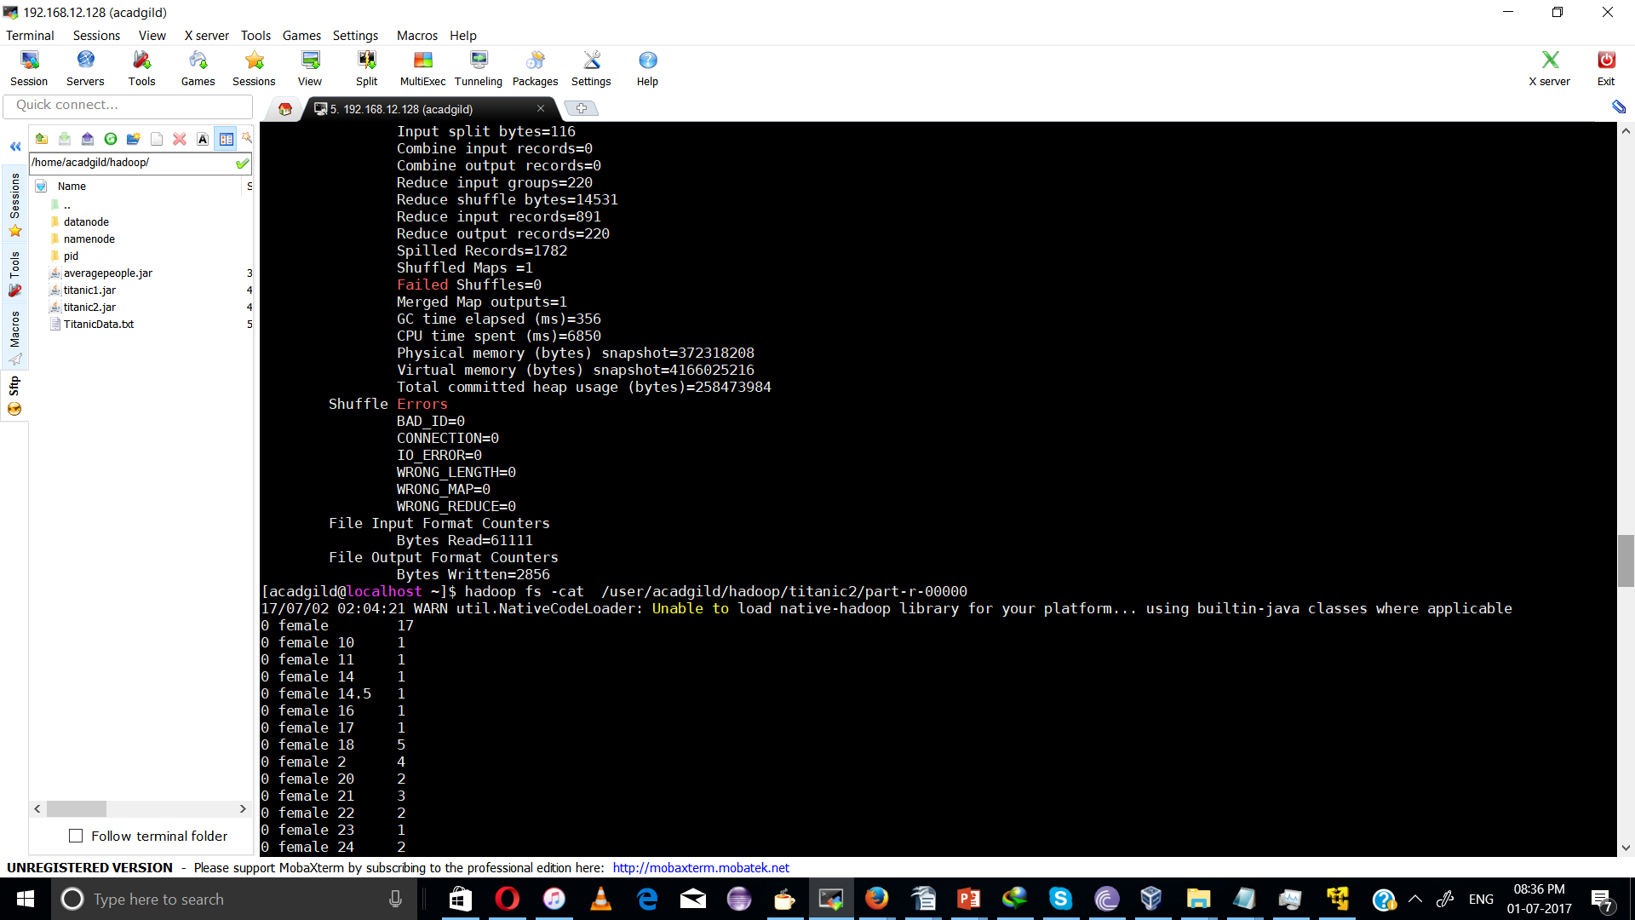

output:
